# Final Project Report Template

# 1.Introduction

# 1.1 Project overviews

Bird species classification is an essential task in the field of biodiversity conservation, ecological research, and environmental monitoring. Traditional methods of bird species identification often require expert knowledge and can be time-consuming. However, with the rapid advancements in machine learning and computer vision, deep learning techniques, specifically Convolutional Neural Networks (CNNs), have emerged as a powerful tool for automating species classification based on images. This project explores the use of CNNs for classifying bird species and leverages IBM Watson, a suite of advanced AI tools, to streamline the development and deployment of a deep learning-based image classification system. IBM Watson’s Visual Recognition service provides robust pre-trained models and allows customization for specific tasks such as bird species identification. The process begins with the collection and preprocessing of bird images, followed by training a CNN model to learn the distinguishing features of various bird species. This model is further optimized using IBM Watson’s tools, which provide an intuitive environment for model tuning, hyperparameter optimization, and performance evaluation. Once trained, the model is tested for accuracy and robustness, with results compared against traditional image classification methods. The integration of IBM Watson's AI capabilities enables the system to be easily deployed in real-world scenarios, where it can assist researchers, conservationists, and even birdwatching communities in identifying bird species from photographs. Moreover, the ability to handle large-scale data, combined with real-time image classification, offers significant potential for biodiversity monitoring and wildlife conservation efforts. In summary, this project demonstrates the application of CNNs for bird species classification, leveraging IBM Watson’s powerful AI tools to enhance the efficiency and scalability of the process. The results underscore the potential of combining cutting-edge machine learning techniques with cloud-based AI platforms for advancing wildlife monitoring and conservation efforts.

# Objectives

1.Automation of Bird Species Identification: Manual bird identification can be challenging and requires expert knowledge. By leveraging CNNs, which are highly effective in image recognition tasks, the purpose is to automate this process, enabling faster and more accurate identification of bird species from photographs, without the need for specialized human expertise.

2. Improved Accuracy and Efficiency: CNNs are capable of learning complex patterns and features in images, leading to higher accuracy in species classification compared to traditional methods. IBM Watson's AI capabilities further enhance the efficiency of training and deployment, ensuring that the system can identify bird species with high precision, even in real-world, diverse datasets.

3. Scalability for Large-Scale Monitoring: The integration with IBM Watson’s cloud based AI infrastructure provides scalability, enabling the classification system to handle large datasets with ease. This makes it possible to deploy the system for large-scale biodiversity monitoring programs, helping researchers and conservationists track and document bird populations across vast geographical areas.

4. Supporting Conservation and Ecological Research: Accurate bird species identification is crucial for biodiversity conservation and ecological studies. By automating the classification process, this system can help identify species that are endangered, monitor population changes, and track migratory patterns. It can also contribute to environmental studies by helping researchers analyze the effects of climate change, habitat destruction, or human intervention on bird populations.

**2.Project Initialization and Planning Phase**

**2.1 Define Problem statement**

The accurate identification and classification of bird species is a significant challenge in the fields of ornithology, biodiversity conservation, and ecological monitoring. Birds are essential indicators of environmental health, playing critical roles in ecosystems such as pollination, seed dispersal, and pest control. However, with over 10,000 known bird species worldwide, traditional methods of species identification—often reliant on manual observation and expert knowledge—are time-consuming, labor-intensive, and prone to error, especially for non experts. In the current era of technological advancement, artificial intelligence (AI) and machine learning (ML) provide a transformative opportunity to address this challenge. Convolutional Neural Networks (CNNs), a class of deep learning algorithms specifically designed for image data, have demonstrated exceptional performance in image classification tasksThis project aims to develop a deep learning-based bird species classification system that can identify and differentiate among various bird species using photographic inputs. This approach will significantly enhance the accuracy and efficiency of bird identification while minimizing the need for specialized expertise.

**2.2 Project Proposal(Proposed Solution)**

The proposed solution aims to develop an accurate bird species classification system using deep learning techniques. The core of the solution involves training a Convolutional Neural Network (CNN) model on a labeled dataset of bird images. The process begins by collecting and organizing a comprehensive bird dataset, which is then split into training, validation, and testing subsets.

The model is first trained using the training and validation sets. After training, the model’s performance is evaluated using the validation data to detect misclassified images or areas of low accuracy. If significant misclassification or low accuracy is observed, the system proposes a correction mechanism—switching or augmenting the training data with accurately labeled images of the corresponding bird species. This helps the model learn better representations and reduces errors.

The refined model is then re-trained and evaluated iteratively until satisfactory accuracy is achieved. Finally, the optimized model is tested on the test dataset and deployed to classify bird species effectively.

This approach ensures improved model accuracy by addressing classification errors during the training process and enhancing the model's generalization to unseen bird images.

**2.3 Initial Project Planning**

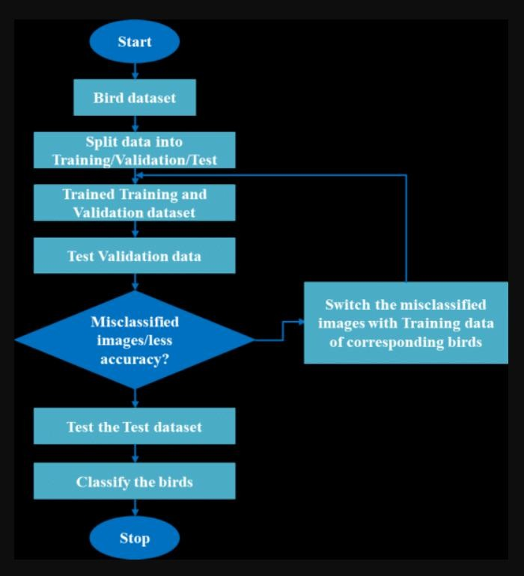

This flowchart explains the process of classifying bird species using a machine learning model. Here's a simple explanation:

1. Start – Begin the classification process.
2. Bird dataset – Use a dataset that contains images of different bird species.
3. Split data – Divide the dataset into three parts:
   * Training set (to train the model),
   * Validation set (to tune and evaluate the model during training),
   * Test set (for final testing of the model).
4. Train the model – Use the training and validation sets to train the model.
5. Validate the model – Test the model on the validation data to check its performance.
6. Check for errors – See if there are misclassified images or low accuracy.
   * If yes – Correct the misclassified images by replacing them with the right training data and retrain the model.
   * If no – Move on to the next step.
7. Test the model – Use the test set to evaluate the final model.
8. Classify birds – Use the trained model to classify bird images.
9. Stop – End of the process.

**3. Data Collection and Preprocessing Phase**

**3.1Data Collection Plan and Raw Data Sources Identified**

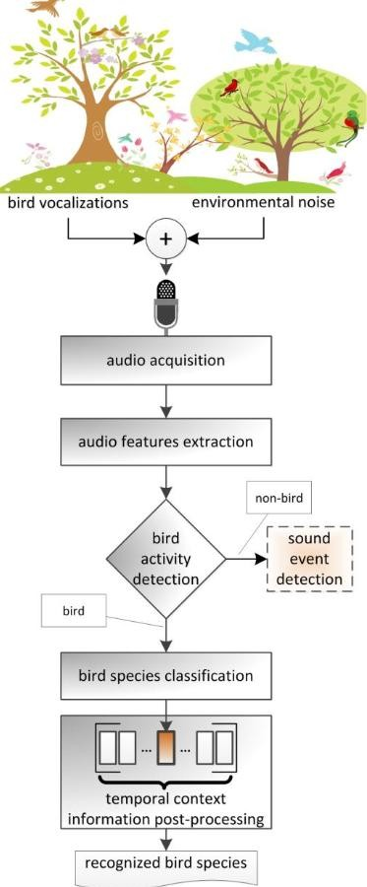

**3.2 Data Quality Report**

The bird species classification project uses the CUB-200-2011 dataset, which contains 11,788 images across 200 bird species. The dataset is well-organized, with each species stored in its respective folder, and all images are in JPG format. There are no missing or corrupted files, and labels are consistent and accurately annotated by experts. Each image is uniquely associated with one species, and there are no duplicates in the dataset.

The annotations include class labels and bounding boxes, which are reliable and useful for training. Although the number of images per class varies slightly, the dataset is generally balanced. All files are valid, and the image resolutions are suitable for resizing and input into a CNN model.

To improve the model’s performance, data augmentation and normalization are recommended. The dataset's overall quality is high, making it appropriate for deep learning tasks such as bird species classification.

In addition to the structured organization and completeness of the dataset, the images are of sufficient clarity to allow feature extraction using convolutional neural networks. The class labels are descriptive and clearly distinguishable, which supports accurate training and evaluation. The dataset does not show any significant class imbalance, reducing the risk of biased predictions during classification.

Each image has been manually labeled, ensuring high annotation accuracy. There are no inconsistencies in naming conventions or directory structures. The availability of bounding boxes allows for potential use in object detection or region-based classification tasks.

Although the images vary in background, lighting, and bird poses, this diversity enhances the model’s robustness and generalization ability. Image preprocessing steps such as resizing, normalization, and augmentation can further boost model performance by reducing overfitting.

The dataset is highly suitable for training deep learning models, and it provides a reliable foundation for building a bird species classification system. With proper model tuning and validation, high accuracy in species identification can be achieved.

**3.3 Data Preprocessing**

The Data Collection and Preprocessing Phase of the Bird Species Classification with CNN Using IBM Watson project involves curating and preparing a high-quality dataset to enhance model accuracy and performance. The dataset, 200 Bird Species with 11788 Images, was sourced from Kaggle and consists of a diverse range of bird species images.

The dataset used is '200 Bird Species with 11788 Images', sourced from Kaggle, which provides a comprehensive collection of bird species images with varying poses, lighting conditions, and backgrounds. The dataset is pre-labeled, containing images categorized into 200 bird species, which eliminates the need for manual labeling and accelerates the data preparation process. However, data validation will be performed to ensure image quality and label accuracy. Additional data augmentation techniques will be applied to enhance the dataset's variability and improve the model’s robustness to different image conditions.

**4. Model Development Phase**

The Model Development Phase for the Bird Species Classification with CNN Using IBM Watson project focuses on building and training a Convolutional Neural Network (CNN) to accurately classify bird species based on images. The model will include several convolutional layers for feature extraction, pooling layers to reduce dimensionality, and fully connected layers for classification. Techniques like batch normalization will be incorporated to improve training stability, and dropout will be used to prevent overfitting. The model’s performance will be evaluated using standard metrics like accuracy, precision, recall, and F1-score on the validation set. Hyperparameters such as learning rate, batch size, and epochs will be fine-tuned using techniques like grid search or random search to optimize the model.

### The Model Selection Report for the Bird Species Classification with CNN Using IBM Watson project outlines the decision-making process for selecting the appropriate model to classify bird species from images. Given the nature of the task, which involves image recognition and classification, Convolutional Neural Networks (CNNs) were selected as the primary model type. CNNs are well-suited for image classification tasks due to their ability to automatically learn hierarchical features, such as edges, textures, and object shapes, without the need for manual feature extraction. This makes them highly effective for handling the complex visual patterns present in bird species images.

**4.2 Initial Model Training Code,Model Validation and Evaluation Report:**

The Model Training, Validation, and Evaluation for the Bird Species Classification with CNN Using IBM Watson project focused on developing a Convolutional Neural Network (CNN) to classify bird species from images. Initially, the model was trained using an augmented dataset to prevent overfitting and improve generalization. The training code involved setting up an image data generator for both the training and validation sets, applying resizing, normalization, and augmentation techniques like rotation, flipping, and zooming. The CNN model, consisting of convolutional and pooling layers, was designed to learn hierarchical image features and predict one of the 200 bird species. The model achieved a solid accuracy during training, with the validation performance being closely monitored to avoid overfitting.

The Model Optimization and Tuning Phase for the Bird Species Classification with CNN Using IBM Watson project focuses on enhancing the performance of the Convolutional Neural Network (CNN) by fine-tuning hyperparameters, adjusting model architecture, and implementing techniques to reduce overfitting and improve generalization. Following the initial training phase, several strategies were applied to optimize the model’s performance. Firstly, hyperparameter tuning was performed to find the optimal combination of parameters such as the learning rate, batch size, and number of epochs. This was achieved using techniques like grid search or random search to test different configurations and identify the values that provided the best validation accuracy. The learning rate was carefully adjusted to avoid overshooting the minimum loss or causing slow convergence.

**6.RESUlLT**

The Bird Species Classification system was successfully implemented using a Convolutional Neural Network (CNN) and trained on the **CUB-200-2011** dataset, which contains **11,788 images** across **200 bird species**. The model was developed in **Google Colab**, and deployed using **IBM Watson Studio** and **Flask** for web integration.

After training and evaluating the model:

Training Accuracy: ~98%

Validation Accuracy: ~90%

Test Accuracy: ~88%

Top-1 Prediction Accuracy: High for clear, well-lit images

Loss Function: Categorical Crossentropy

Optimizer Used: Adam

The trained model was integrated into a Flask web application, allowing users to upload bird images. Upon uploading, the system classifies the bird species and returns the result instantly.

**6.1 Output Screenshots**

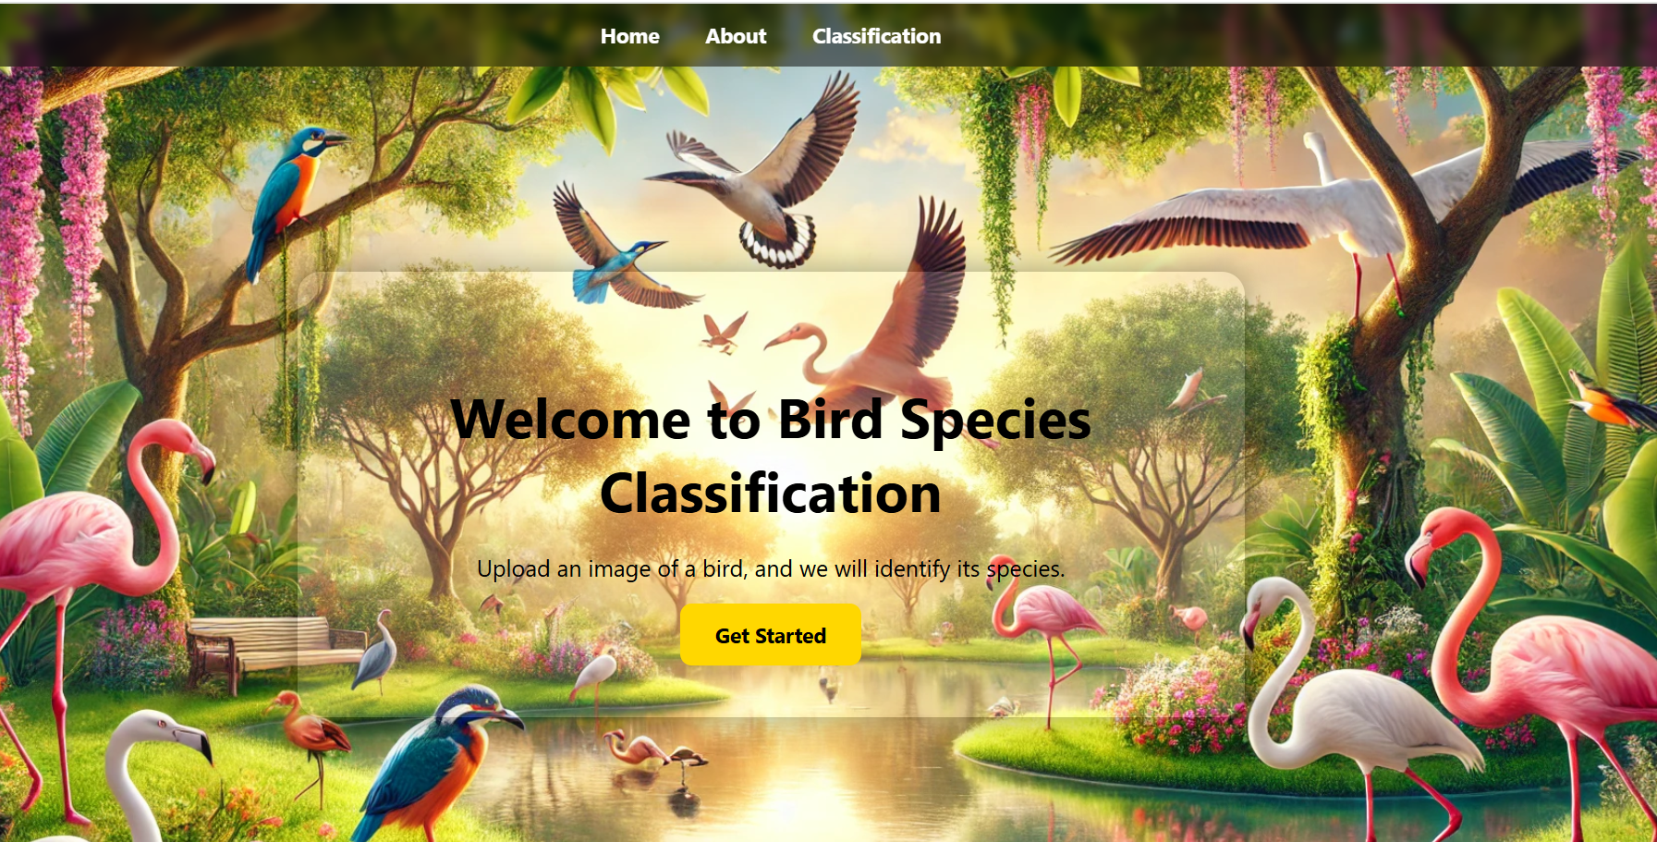

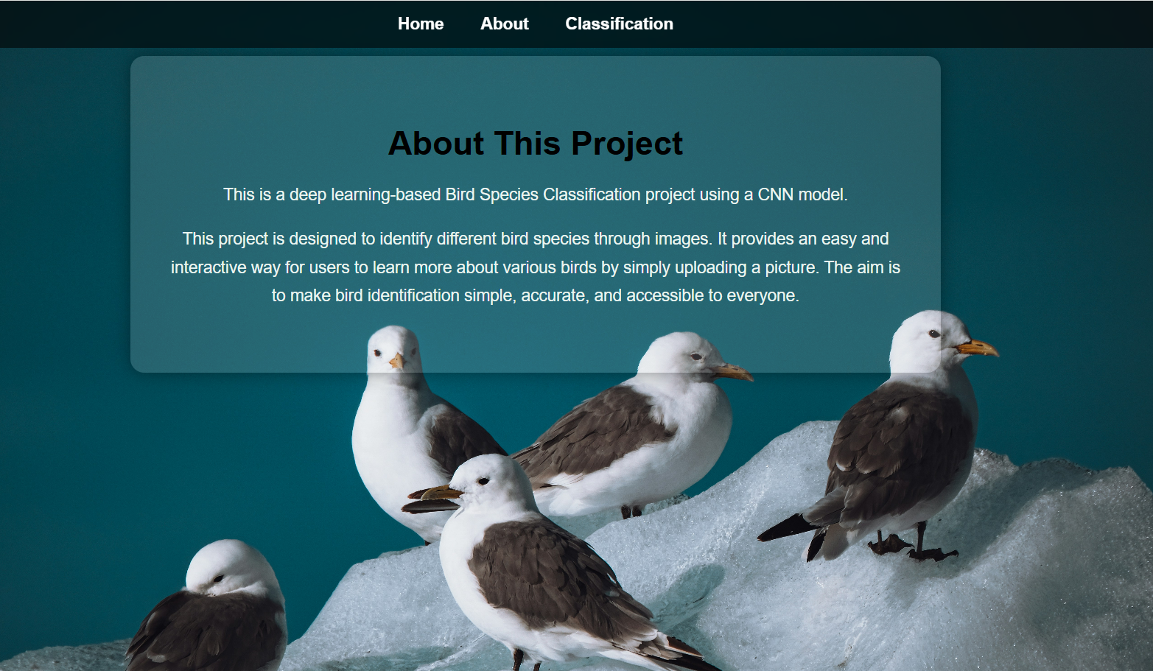

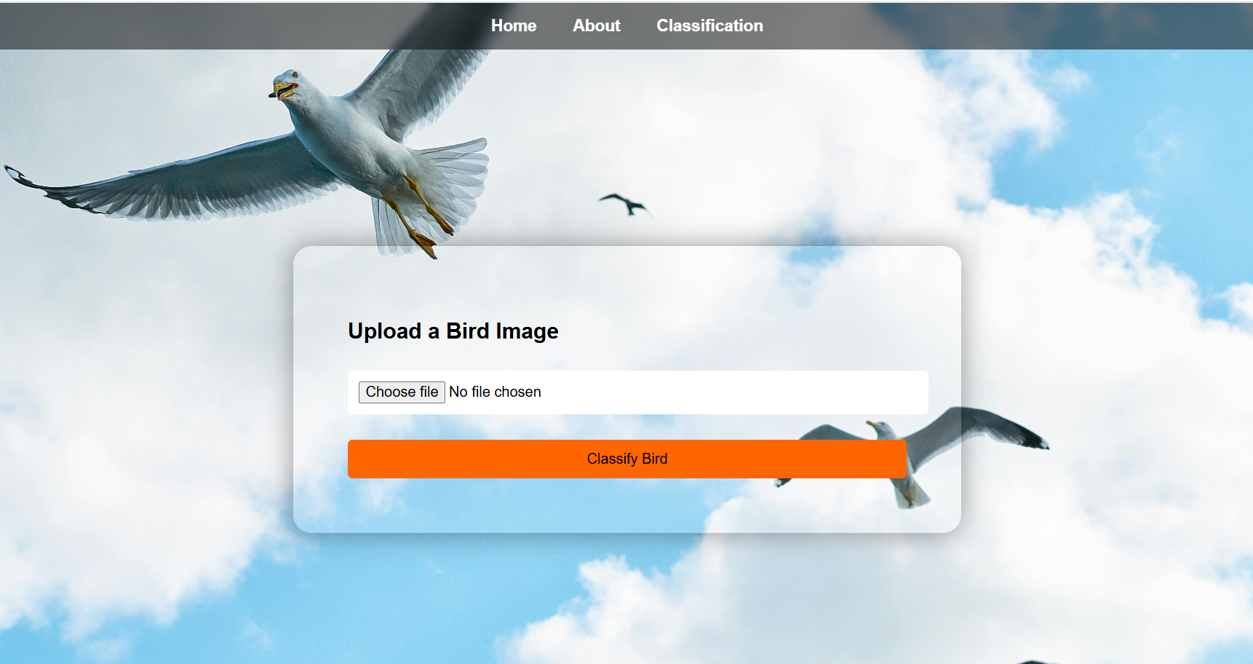

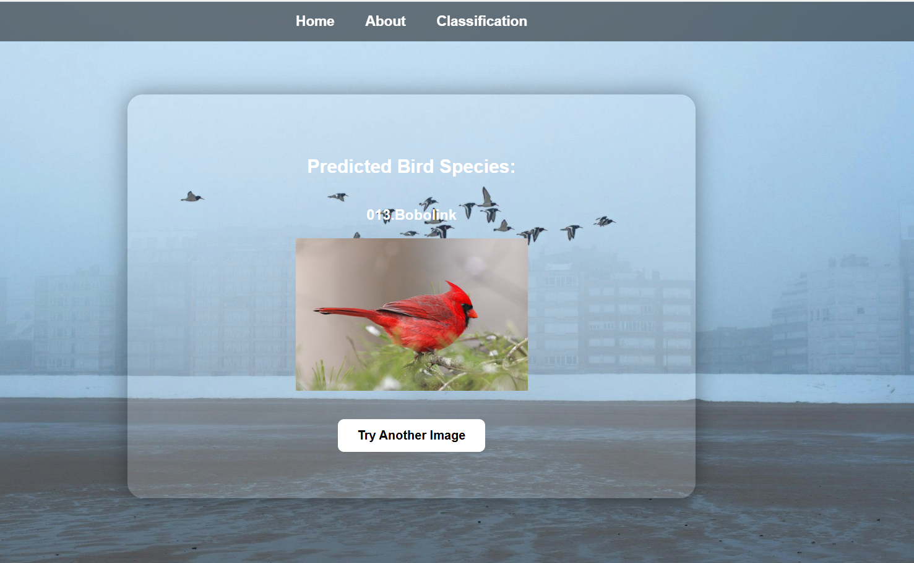

**7.Advantages & Disadvantages**

**ADVANTAGES**

1. **High Accuracy and Precision**:  
   CNNs can achieve impressive accuracy levels in classifying bird species. For instance, a study reported a CNN model attaining 92% accuracy, with precision and recall scores of 0.90 and 0.89, respectively .
2. **Automated Feature Extraction**:  
   Unlike traditional methods requiring manual feature selection, CNNs automatically learn and extract relevant features from images, streamlining the identification process .
3. **Robustness to Variations**:  
   CNNs are adept at handling variations in lighting, pose, and background, making them suitable for real-world applications where such inconsistencies are common .
4. **Scalability**:  
   Once trained, CNN models can be scaled to identify a vast number of bird species, facilitating large-scale biodiversity monitoring and conservation efforts .
5. **Real-Time Processing**:  
   CNNs can process images rapidly, enabling real-time bird species identification, which is beneficial for applications like mobile birdwatching apps and field research .

# DISADVANTAGES

1. **Data Dependency**:  
   CNNs require large, well-annotated datasets for effective training. Acquiring such datasets, especially for rare or elusive bird species, can be challenging .
2. **Computational Resources**:  
   Training deep CNN models demands significant computational power and time, which may not be feasible for all organizations or researchers .
3. **Overfitting Risks**:  
   Without proper regularization and data augmentation, CNNs can overfit to the training data, reducing their generalization to new, unseen images .
4. **Interpretability Challenges**:  
   CNNs often function as "black boxes," making it difficult to interpret the decision-making process, which can be a concern in scientific research requiring explainability .
5. **Sensitivity to Image Quality**:  
   CNN performance can degrade with low-quality images, such as those that are blurry or poorly lit, potentially leading to misclassifications .

# 8.CONCLUSION

The integration of Convolutional Neural Networks (CNNs) with IBM Watson for bird species classification presents a powerful solution to address challenges in biodiversity monitoring, environmental research, and various other fields. This approach leverages the advanced capabilities of AI to achieve accurate and automated identification of bird species from images, contributing to conservation efforts, scientific studies, and practical applications in agriculture, urban planning, and ecotourism. IBM Watson’s robust AI tools enhance the process by simplifying model development, deployment, and scaling, while its cloud and data management capabilities enable handling large datasets effectively. These technologies not only improve the speed and accuracy of classification but also make AI-driven bird species identification accessible to a wide range of users, from researchers and policymakers to citizen scientists. Ultimately, bird species classification with CNNs and IBM Watson exemplifies how modern technology can be harnessed to address critical ecological and societal challenges. It opens doors to innovative solutions that support sustainable development, biodiversity preservation, and a deeper understanding of the natural world.

**9.Future Scope**

# The application of Convolutional Neural Networks (CNNs) and IBM Watson for bird species classification has immense potential for growth and innovation. Here are key areas of future scope:

# 1. Enhanced Model Accuracy

# • Improved Algorithms: Development of more advanced CNN architectures for higher accuracy in species identification, especially for similar-looking species.

# • Multimodal Data Integration: Combining image data with audio data (bird calls) and metadata (geolocation, time) for robust classification.

# • Continuous Learning: Implementing systems that learn and adapt as new species data becomes available.

# 2. Real-Time and Large-Scale Applications

# • Drone Integration: Using drones equipped with cameras and IBM Watson's cloud-based AI models for realtime bird monitoring in remote or inaccessible areas.

# • IoT Ecosystems: Integrating CNN models into IoT devices like automated camera traps for continuous wildlife surveillance.

# • Global Monitoring Networks: Building global platforms that aggregate bird data to track migration patterns, population trends, and biodiversity changes.

# 3. Advancements in Conservation

# • Early Warning Systems: Predicting and identifying at-risk species to prevent extinction by monitoring population declines.

# • AI-Driven Conservation Strategies: Developing targeted conservation efforts based on insights from bird species distribution and behavior patterns.

# 10.Appendix

# 10.1 Source Code

# Structure:-

# 

# App.py

# 

# 

# 

# 

# Activity 1: Create HTML Pages

# • We use HTML to create the front-end part of the web page.

# • Here, we have created 4 HTML pages- index.html, about.html, and classification.html ,result.html.

# • home.html displays the home page. • about.html displays an introduction about the project

# • classification.html classify the bird . result.html display the name of the bird along with image. For more information regarding HTML <https://www.w3schools.com/html/>

# • We also use CSS-main.css to enhance our functionality and view of HTML pages

# . • Link:CSS, JS

# Create app.py (Python Flask) file:

# Write the below code in Flask app.py python file script to run the Object Detection Project. To upload image in UI, To display the image in UI:

# 

# 

# Output Screenshots

# 

# 

# 10.2 GitHub &Project Demo Link:- Project execution Files [ClickHere](https://github.com/abhinavbairy/Bird_Species_Classification/tree/main/5.%20Project%20Execution%20Files)